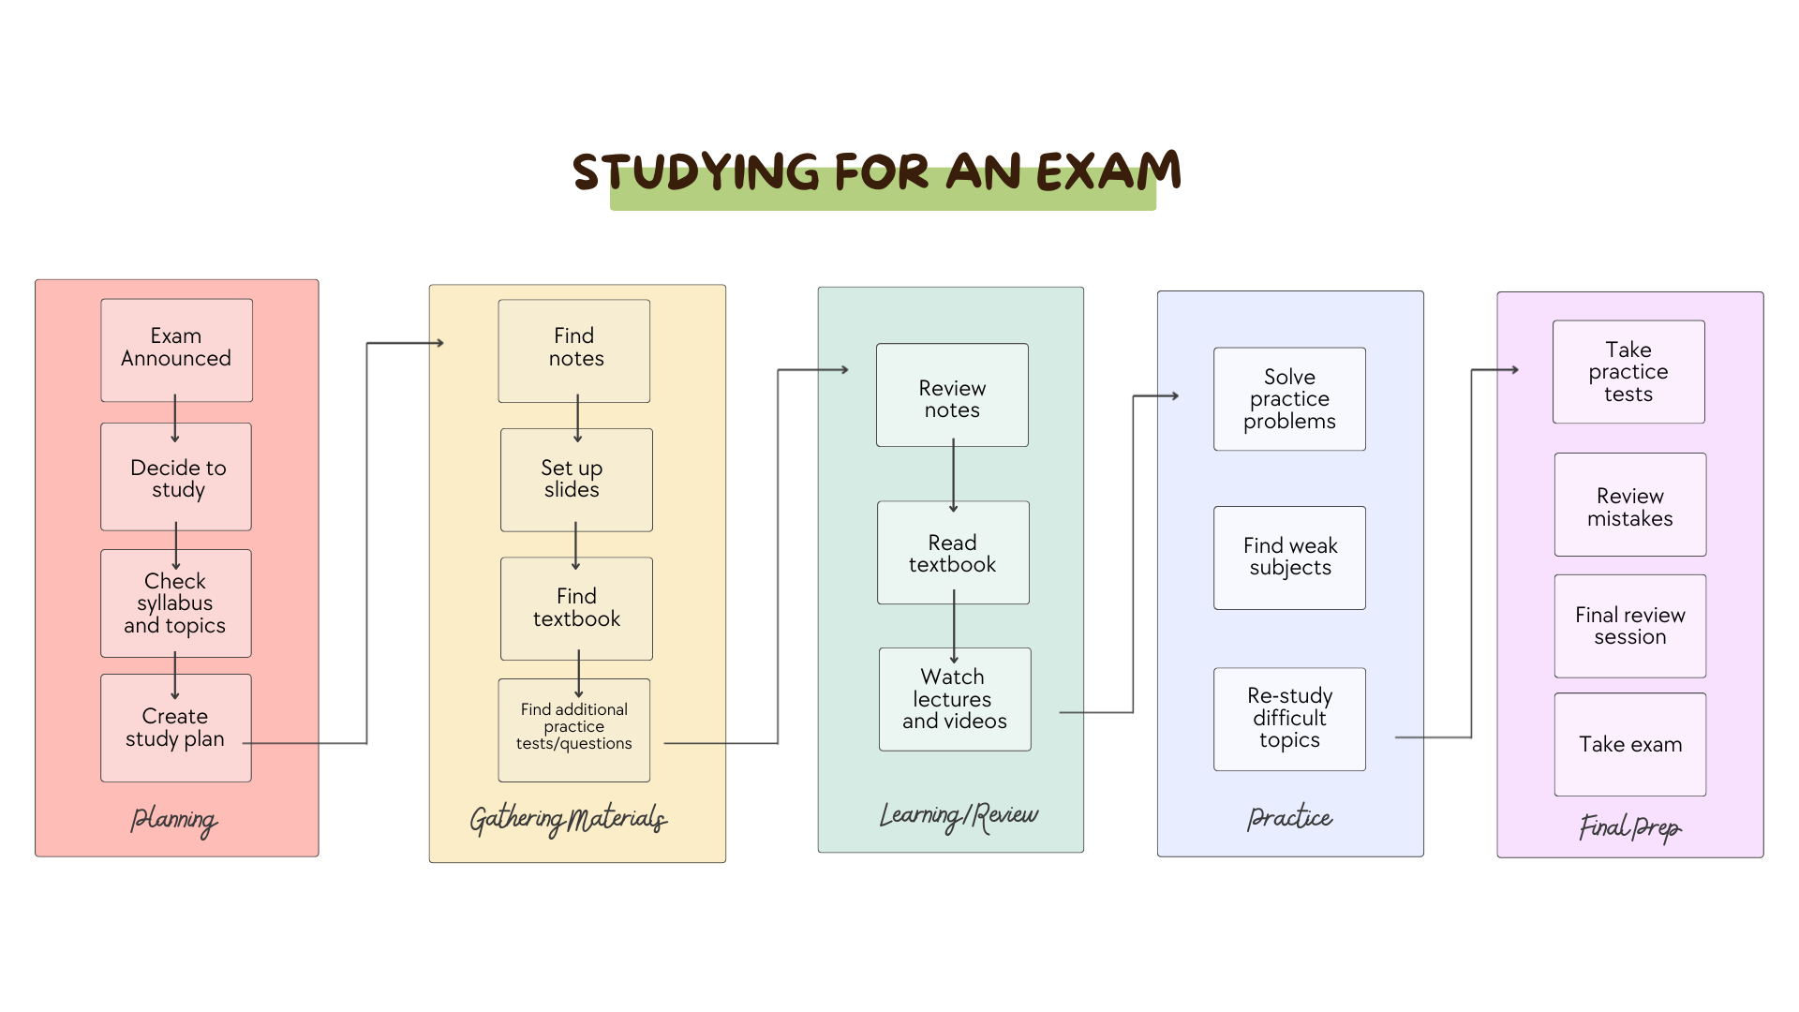
Estimated Time Flow

Planning | 1 hour
Gathering Materials | 30 minutes
Learning/Review | 6 hours
Practice | 4 hours
Final Prep | 3 hours

Estimated Time Cycle: ~14.5 hours

Optimizing my process:

- Eliminating waste
  - I can start studying earlier to help reduce procrastination delays.
  - I can limit distractions by silencing my phone or using website blockers.
  - I can prepare study materials ahead of time to avoid searching during study sessions.
  - I can study in a quiet, dedicated space to maintain focus.
- Improve flow and organization
  - I can create a structured study schedule with specific goals per session
  - I can break large optics into smaller manageable chunks
  - I can use timed sessions (Pomodoro Technique) to maintain productivity
  - I can track progress to avoid redundant studying
- Reduce rework
  - I can summarize my notes into concise study guides
  - I can use spaced repetition to retain information long-term
  - I can take practice tests earlier to identify gaps sooner

References
Innopharma. (2024, September 27). How to be productive when studying: 10 hacks and tips. Innopharma Education. https://www.innopharmaeducation.com/blog/how-to-be-productive-when-studying-10-hacks-and-tips
Scroggs, L. (2021, January 14). The Pomodoro Technique. todoist. https://www.todoist.com/productivity-methods/pomodoro-technique

